|  |
| --- |
|  |
| Enterprise Architecture and Agile |
|  |
|  |
| **Antriksh Kumar (ID : 15892136)**  **Amar Kashari (ID : 1410125)**  **Hao Zhang (ID : 14857609)** |
| **Submission Date : 14-Aug-2015** |

|  |
| --- |
|  |

**Introduction**

*Enterprise Architecture*

Different people have different views about Enterprise Architecture (EA). To illustrate the overall conceptions of EA we are presenting two different definitions of EA:

EABOK: ‘Enterprise Architecture analyzes areas of common activity within or between organizations where information and other resources are exchanged to guide future states from an integrated viewpoint of strategy, business and technology.’ (Enterprise Architecture body of knowledge)

Gartner: ‘Enterprise architecture (EA) is a discipline for proactively and holistically leading enterprise responses to disruptive forces by identifying and analyzing the execution of change towards desired business vision and outcomes. EA delivers value by presenting business and IT leaders with signature-ready recommendations for adjusting policies and projects to achieve target business outcomes that capitalize on relevant business disruptions. EA is used to steer decision making towards the evolution of the future state architecture’ (Gartner IT Glossary).

From these definitions, we understand that EA is organizational level guidance and standard that leads an organization towards its goal using the values and vision of EA. In other words, EA is like the wheels of a car to provide support while Agile is the engine to push it forward.

*Definition of Agile*

In the scope of software development, according to the Agile Manifesto, Agile is defined as:

“Individuals and interactions over processes and tools;

Working software over comprehensive documentation;

Customer collaboration over contract negotiation;

Responding to change over following a plan.” ([Beck et al., 2001)](https://docs.google.com/document/d/1icZgcBCfGYAnro4OTv2RH-NjRd75Y0RhQ5jw5Ou2Wjc/edit#heading=h.30j0zll)

The term Agile in software development is considered to be a better connection between each stakeholder. Faster iterations as compared to the previous plan-and-document approach are considered to be less likely to fail the project or are likely to provide some usable products instead of useless documents in case of failure.

*Criteria of Agility*

In the study of Qumer and Henderson-Sellers ([2006)](https://docs.google.com/document/d/1icZgcBCfGYAnro4OTv2RH-NjRd75Y0RhQ5jw5Ou2Wjc/edit#heading=h.1fob9te), a tool to evaluate the four degrees of agility of different agile methods is introduced, which is named as 4-Dimensional Analytical Tool (4-DAT). As this tool is generic ([Qumer, Henderson-Sellers, & McBride, 2007)](https://docs.google.com/document/d/1icZgcBCfGYAnro4OTv2RH-NjRd75Y0RhQ5jw5Ou2Wjc/edit" \l "heading=h.tyjcwt), it can also be used to evaluate the agility of non-agile practices. To use the tool, [Qumer and Henderson-Sellers (2008a)](https://docs.google.com/document/d/1icZgcBCfGYAnro4OTv2RH-NjRd75Y0RhQ5jw5Ou2Wjc/edit#heading=h.3znysh7) break apart development methods into “phases” and “practices”. The term “phases” represents each step of the method while “practices” indicates the actual practices used in the methods. Each method’s agility criteria are measured through binary numbers (1 for yes, 0 for no). Finally, the agility of the methods is quantitatively measured through calculation.

The criteria of evaluating agility, based on the theory from [Qumer and Henderson-Sellers (2008a, p. 282)](https://docs.google.com/document/d/1icZgcBCfGYAnro4OTv2RH-NjRd75Y0RhQ5jw5Ou2Wjc/edit#heading=h.3znysh7), are considered to be:

|  |  |
| --- | --- |
| Flexibility | Does the method accommodate expected or unexpected changes? |
| Speed | Does the method produce results quickly? |
| Leanness | Does the method follow the shortest time span, use economical, simple and quality instruments for production? |
| Learning | Does the method apply updated prior knowledge and experience to create a learning environment? |
| Responsiveness | Does the method exhibit sensitiveness? |

In the work of Qumer and Henderson-Sellers ([2008b)](https://docs.google.com/document/d/1icZgcBCfGYAnro4OTv2RH-NjRd75Y0RhQ5jw5Ou2Wjc/edit#heading=h.2et92p0), 4-DAT is a component of Agile Software Solution Framework (ASSF), which is a meta-model (taxonomy) for agile software development methodologies. While in the work of [Qumer et al. (2007)](https://docs.google.com/document/d/1icZgcBCfGYAnro4OTv2RH-NjRd75Y0RhQ5jw5Ou2Wjc/edit#heading=h.tyjcwt), they introduced Agile Adoption and Improvement Model (AAIM) which consists of six levels representing maturity level (process) of agile methods.

The role of AASF is to assist executives to understand the architecture of an agile group, and to provide quantitative tools to measure “agility” of an agile method (Qumer & Henderson-Sellers, 2008b), whereas AAIM provides a long term evolution model of agile organization, including three major blocks and six AAIM level (Qumer & Henderson-Sellers, 2008b).

*Enterprise Architecture and Agile*

The first EA was introduced way back in 1987(i.e. 28 years ago) while Agile is comparatively a new methodology. Agile, is more focused on project delivery as it guides the development team in their everyday activities (daily stand up etc.) whereas Enterprise Architecture is organizational level focussing on the long term organization goals.

So, what is the relationship between them and why we are bringing these two subjects together?

There are two parts for the answer to this question.

1. Most EAs were designed to work with waterfall methodology but since most companies today use Agile, a need arises to create a new EA that fits with Agile.
2. Agile has been very successful compared to waterfall methodology but it lacks the high level guidance to ensure the work that we are doing on the everyday basis is going in the right direction.

**Research question**

Previously, EA worked with waterfall and other document-and-plan methods to achieve business value. Nowadays, Agile has gradually replaced document-and-plan approach and become a standard in software development industry, especially in small projects, but EA has not changed too much.

In this paper we are going to compare the top five EAs (Zachman, TOGAF, FEA and Gartner) (Sessions) to examine which one of them is more suitable for Agile.

**Methodology**

Quantitative research methodology is going to be used to compare the various attributes of the five Enterprise architectures and based on the result the EA which is most suitable with Agile is going to be identified.

**Research design and method**

Our first step is to know about:

* What is Agile/Agility?
* What is the Criteria of Agile?
* What is EA?
* Which are the top EAs?

Till now we have got an overview of Agile, most popular EAs and comparison between different EAs. We have also seen a few criteria that can be used to measure agility. There are many other authors who have defined different criteria of agility; however, we chose ASSF and AAIM as they provide mature and quantitative measurement of agility.

*Next Steps*:

Our next step will be to get a deeper understanding of EA and Agile. Once we are clear about the criteria that can be used to measure Agile/Agility and how to connect that criteria with Enterprise Architecture, the different EAs will be marked on those criteria.

In this way we will be able to compare various Enterprise Architectures and come out with the EA that is best suited for Agile.

**Significance of Research**

With this research we will try to find that one Enterprise Architecture which is most compatible with Agile. The objective of answering this research question is that there is a need for an Enterprise Architecture that can go hand in hand with Agile which in turn will help the whole organization in terms of better performance, reliable results, and most of all increased return on investment.

**Timelines**

Below is our plan:

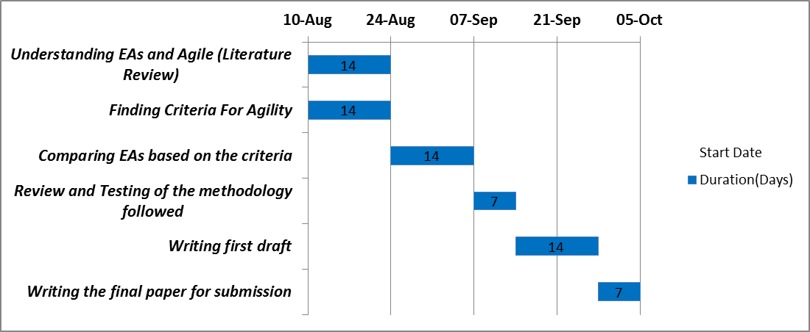

|  |  |  |  |
| --- | --- | --- | --- |
| **Task Name** | **Start Date** | **End Date** | **Duration(Days)** |
| Understanding EAs and Agile (Literature Review) | 10-Aug | 23-Aug | 14 |
| Finding Criteria For Agility | 10-Aug | 23-Aug | 14 |
| Comparing EAs based on the criteria | 24-Aug | 06-Sep | 14 |
| Review and Testing of the methodology followed | 07-Sep | 13-Sep | 7 |
| Writing first draft | 14-Sep | 27-Sep | 14 |
| Writing the final paper for submission | 28-Sep | 04-Oct | 7 |

We have divided our work in the below way:

Hao:

* Finding out the criteria to evaluate agile/agility.

Amar:

* Comparing the different types of Enterprise Architectures among themselves.

Antriksh:

* Finding out the relationships between Agile and different Enterprise Architectures.

The rest of the tasks like review and testing of the methodology, writing the paper etc. will be equally divided among everyone.

**References**

Beck, K., Beedle, M., Van Bennekum, A., Cockburn, A., Cunningham, W., Fowler, M., . . . Jeffries, R. (2001). Manifesto for agile software development.

Enterprise Architecture body of knowledge,. 'Enterprise Architecture Body Of Knowledge (EABOK) | Home'. N.p., 2015. Web. 8 Aug. 2015.

Gartner IT Glossary,. 'Enterprise Architecture - EA - Gartner IT Glossary'. N.p., 2012. Web. 8 Aug. 2015.

Qumer, A., & Henderson-Sellers, B. (2006). *Measuring agility and adoptability of agile methods: a 4-dimensional analytical tool.* Paper presented at the Procs. IADIS International Conference Applied Computing 2006.

Qumer, A., & Henderson-Sellers, B. (2008a). An evaluation of the degree of agility in six agile methods and its applicability for method engineering. *Information and software technology, 50*(4), 280-295.

Qumer, A., & Henderson-Sellers, B. (2008b). A framework to support the evaluation, adoption and improvement of agile methods in practice. *Journal of Systems and Software, 81*(11), 1899-1919.

Qumer, A., Henderson-Sellers, B., & McBride, T. (2007). Agile adoption and improvement model.

Sessions, Roger. 'A Comparison Of The Top Four Enterprise-Architecture Methodologies'. *Msdn.microsoft.com*. N.p., 2015. Web. 8 Aug. 2015.